TravelCrypto White Paper

Contents

1. The reasoning behind the project
   1. Describe the problem and solution

Our Team create TravelCrypto to motivate people travel. We believe that exploring the world makes people more tolerant, happy and free. But while travelling we also have a risk to end up with low budgeting, low service or simply closed places. To avoid it we all watch guides and plan a perfect trip.

To have fun and joy while travelling just but an NFT trip for a night, day or a week. Unforld unique places on the map which bring you bright and fun experience at the location. Just take from the top of the heap and enjoy. Utilizing this NFT you’ll be rewarded with our unique travel tokens and NFTs. You may spend the tokens to create new NFT trip or just get another beer in.

To start we decided to create a unique collection of travel avatars. With this avatar you’ll gain free NFT trip, first tokens and more bonuses in the application. Join our project and ask your questions.

1. The utility and use case
   1. Describe solution in details (how it differs from the competitors)

To allow people travel more our team introduce the application where you may create and use NFT trips. NFT trip is an NFT which contains some trip and reward when you accomplish the task. The application tracks your GEO, registering all places you check in. So you’ll receive a reward only checking in all the steps or places mentioned in an NFT.

But it’s not only about a trip, it’s about create a new NFT for selling it. After going through the trip you’ll receive our token which will give you opportunity to create your own NFT with a reward. And it’s up to you to decide what will it be. A strip bars at Ibiza? Museums in London? Mountain picks in Italy? Sunny beaches of Portugal? You decide what is most intriguing travel experience to sell through NFT.

Further more when you finish the trip from NFT you may turn it into collectible NFT. In future out team will provide an opportunity to create a collection of collectibles. Worth of mentioning that while travelling and checking in the places you have a chance of drop of rare collectibles which will make your collection unique and priceless. When you gather collections and level up you’ll be ready for the next step.

Final step of our plan is to bring Exhibitions of collections inside the application. All users may join the exhibition and watch the collections to inspire travelling. And it’s a chance to sell your collection if you want to for a best price. Our team doesn’t want to dictate which exhibitions to organize, we want our users to decide. So most engaged users will get the opportunity to create their own events.

To sum up our application will give our users ability to use our tokens to create trip and collectible NFTs, to engage and share travelling experience through these NFTs and get feedback and appreciation through events. However, we plan to add brands here which will make NFT market even more interesting because brands will create their own NFTs to empower your collections.

1. The blockchain architecture behind it
   1. Consensus mechanism, Why on blockchain, what is the chain

The team plans to use Solana blockchain for generating project tokens. This is one of the fastest and cheapest blockchains based on proof of work consensus.

1. The token distribution and utility
   1. Tokenomics, how distributed and when, how they’re burnt or limited amount

Token distribution will be the following:

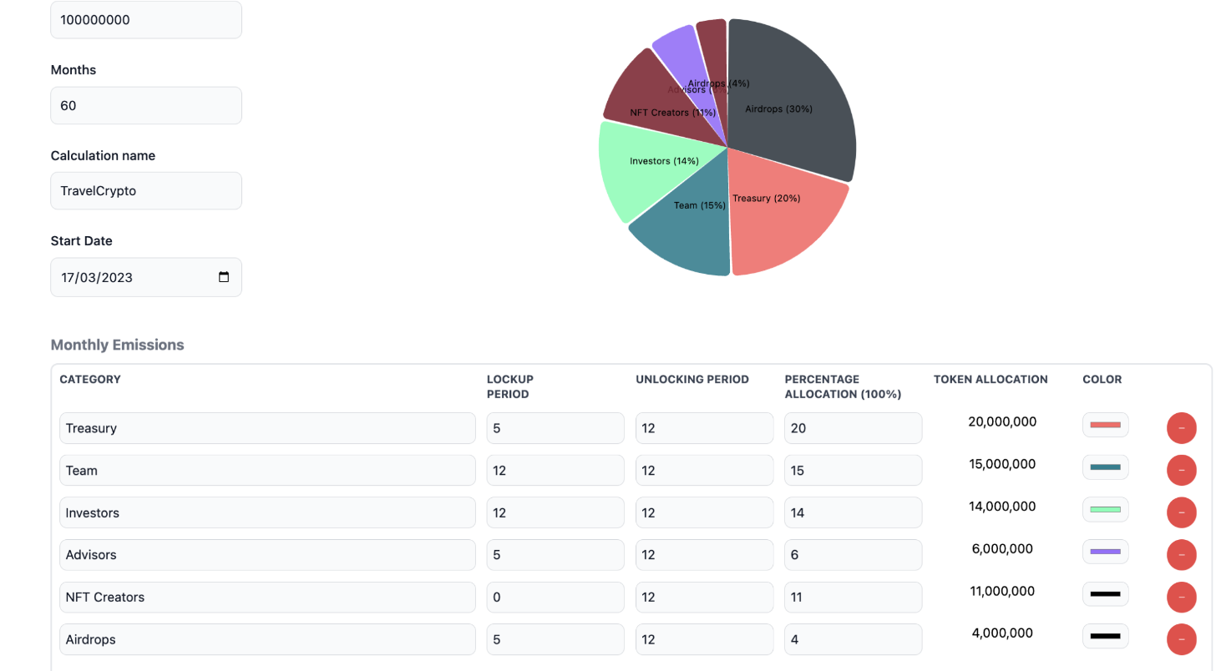

Treasury – 20%

Team – 15%

Investors – 14%

Advisors – 6%

Community – 15%

Token supply – 1.000.000.000. Total supply will be minted at Genesis event. 25% of total supply will be unlocked each decade so in 1 year all tokens will be unlocked.

Tokens for the Team and Investors will be locked for 1 year.

Tokens for Community have no locking period.

Demand:

1. NFT minting
2. Level up
3. NFT improvement
4. Event creation
5. Event participation
6. The Roadmap

1st step – create token infrastructure and NFT avatars collection

2nd step – create application to track geo-location, market, check-in places and create NFT trips. Create 1000 Unique NFT Trips in parallel.

3rd step – Add ability to save used NFT trip as NFT collectible. Add function to create NFT collections.

4th step – Add function to create events and shares collectibles through these events.

Next steps to be outlined during step 3 development.

1. The team behind it (names and credentials)

Our team:

CEO and Product Lead – Evgeniy Cherny

CTO and Architecture – Alexey Osipov

Development Lead – Nick Cherny

2D artist – Ekaterina Bilaya